Intended for Evil (Mr. Pete’s Chair)

Dear Culture Contrarian,

We seem to be seeing an increase in intentional evil. We know Christ’s analysis of the human race, “you being evil…” (Matthew 7:11), but this seems to be far more than natural wrongdoing. Everywhere I turn there appears to be a surge of calculated, planned, well-funded evil that shakes the traditional values of our country to the core.

Where is God in all of this?

Mr. Pete is one of our members who uses his wheelchair to traverse north-central Texas. His chair, a Quantum 6 (top of the line for wheelchairs) stopped working on his way to church some weeks ago. Some folks from the church graciously went and picked up Mr. Pete and brought him to church. BUT his $6k wheelchair was left by the side of the road. When they went back it was gone. Wheelchairs have serial numbers, but 4 men in a pickup truck can make it disappear in seconds. He lost his chair, his phone, and the saddlebags that carry most of Mr. Pete’s life. As I was in North Carolina at the time, I started looking through Facebook Market Place. Sara and I drove an hour to someone selling a similar wheelchair. We paid $500 for a Quantum 6 Edge 3 chair with 8 miles on it (Mr. Pete did 6 times that on his first day!). This chair retails for around $30,000; I know, the price of a car…that can be easily stolen by evil people!

Joseph’s brother plotted, planned, and executed evil against him. They fully intended to have him forever out of their lives. But our God (who only, always, and continually does good) used their evil for the good of the world. “But as for you, you meant evil against me; but God meant it for good, in order to bring it about as it is this day, to save many people alive.” Genesis 50:20.

The ones doing evil will answer to God for their deeds, so that is not something we need to worry about. We can walk with the Lord by His Spirit and know that He works all things together for good, to those who Love Him and are called according to His purpose. (Romans 8:28).

Loaded and Ready to Leave NC  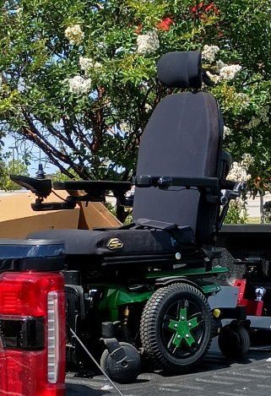 | Put Into God’s Service in Texas  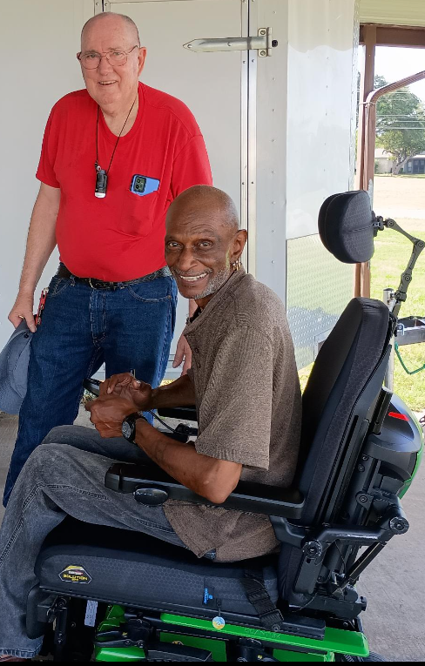

My love to you all,

